3. PROJECT DESIGN PHASE

3.1 Introduction
The Project Design Phase converts the outcomes of the Requirement Analysis Phase into a technical blueprint that can be followed during implementation. While the requirement analysis describes what ContentGen must do, the design phase describes how the system will be structured, how its components will communicate, how data will be organised and how the system will be protected. Decisions made at this stage reduce ambiguity during development and make the system easier to test, extend and maintain.
For ContentGen, the identified requirements cover user registration and login, blog creation and management, AI-assisted blog generation and summarisation, commenting, search, category and tag organisation, and distinct capabilities for four types of users. These functional needs, together with the non-functional needs of security, scalability and maintainability, are translated in this chapter into six design areas: system architecture, database design, API design, security design, AI integration design and user-role design.
ContentGen follows a modular and scalable backend architecture. It is built on Node.js and Express.js, stores its data in MongoDB through the Mongoose Object Data Modelling (ODM) library, uses Google Gemini AI for content generation, and protects its resources with JWT authentication, bcrypt.js password hashing and Role-Based Access Control. Each functional area is implemented as an independent module so that it can be developed, tested and scaled without affecting the others.
Table 3.1: Mapping of design areas to sections of this chapter
Design Area | Purpose | Section
System architecture | Defines the layers and the request flow of the backend | 3.2, 3.3
Module design | Divides the system into cohesive functional modules | 3.4
User-role design | Defines permissions of Admin, Editor, Author and Reader | 3.5
Database design | Defines entities, attributes and relationships | 3.6
API design | Defines the REST interface exposed to clients | 3.7, 3.12
AI integration design | Defines how Google Gemini AI is used | 3.8
Security design | Defines protection of data and endpoints | 3.9
Workflow design | Defines the lifecycle of blog content | 3.10, 3.11

3.2 System Architecture Design
ContentGen is designed as a layered backend system. Every request enters through the Express.js API server and passes through a fixed sequence of components, each with a single responsibility. The standard request flow is:
- Client / Postman: sends an HTTP request to the backend. Postman is used to test the API, and any frontend application can act as a client.
- Express.js API Server: receives the request and hands it to the routing system.
- Authentication and Authorization Middleware: verifies the JWT and checks that the role of the user is allowed to perform the operation.
- Routes: map the URL and HTTP method to the appropriate controller function.
- Controllers: handle the request, validate input and call the required services.
- Services / Business Logic: implement the rules of the application, such as content handling and publishing decisions.
- Mongoose and MongoDB: the services use Mongoose models to read and write data stored in MongoDB.
AI functionality follows a separate integration flow. An AI request is received by the AI Service, which prepares a prompt and sends it to Google Gemini AI. The generated content or summary is returned to the AI Service, processed, and sent back to the client as part of the backend response. Keeping this flow in its own service isolates the external dependency, so that changes to the AI provider affect only one component.
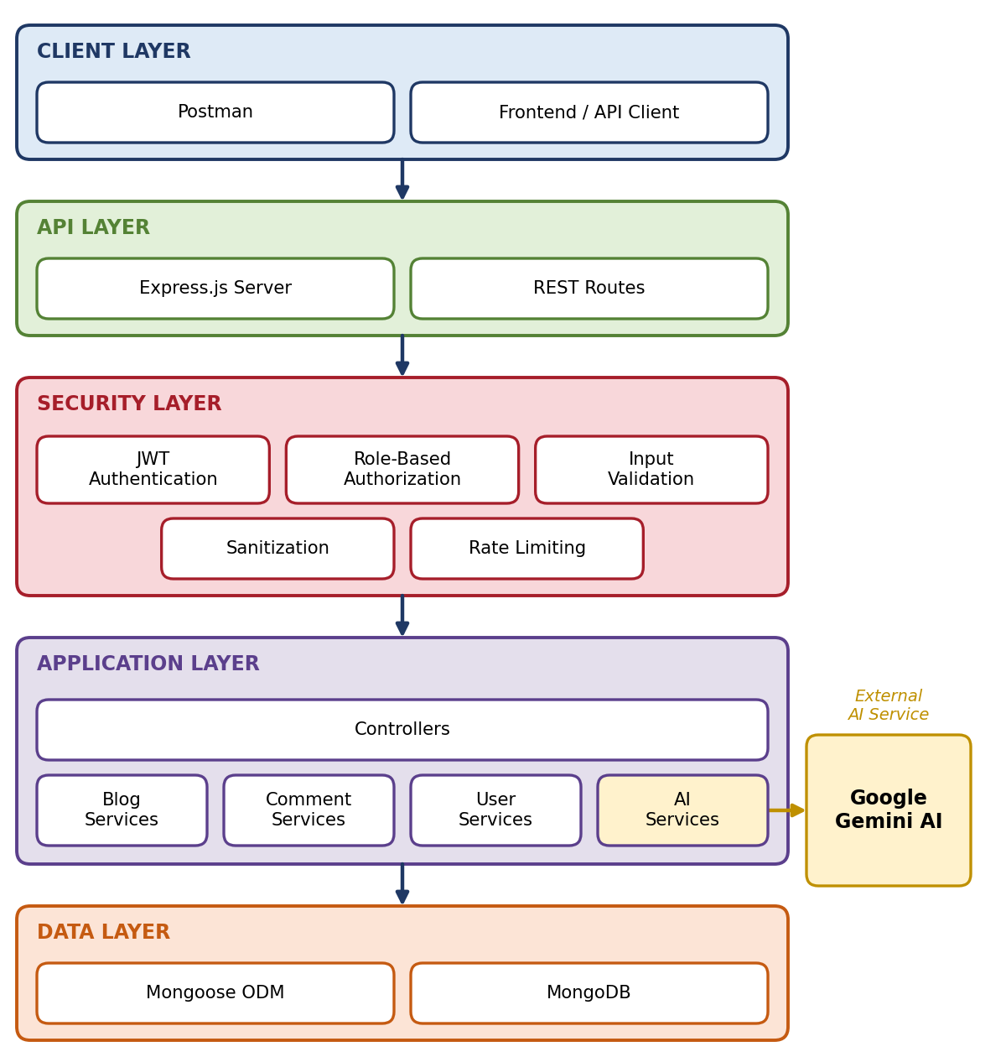
Figure 1: ContentGen System Architecture
As shown in Figure 1, the architecture has five layers. The Client Layer contains the API consumers. The API Layer contains the Express.js server and the REST routes. The Security Layer applies JWT authentication, role-based authorization, validation, sanitization and rate limiting before any business logic is reached. The Application Layer contains the controllers and the Blog, Comment, User and AI services. The Data Layer consists of the Mongoose ODM and the MongoDB database. The AI Services component is additionally connected to the external Google Gemini AI service.

3.3 MVC Architecture Design
The backend applies the Model-View-Controller (MVC) pattern to separate data, request handling and presentation. This separation allows each part of the system to change independently and keeps the codebase organised as it grows.
Model Layer. Models are defined using Mongoose schemas. A schema describes the fields, data types and constraints of a document, and the corresponding model provides the methods used to create, query, update and delete records in MongoDB. The main models of ContentGen are the User Model, Post Model, Comment Model and Category Model. Data rules, such as required fields and unique email addresses, are declared in the schemas so that they are enforced consistently.
Controller Layer. Controllers act as the coordinators of the system. A controller receives a request from a route, validates the input, executes the required business logic by calling models or services, and returns a JSON response with an appropriate HTTP status code. Controllers remain thin: complex operations such as AI communication are delegated to services rather than written inside the controller.
View / API Layer. ContentGen is a headless backend system and does not render HTML pages. The traditional View of MVC is therefore replaced by the REST API interface and the routing layer, which expose resources as URLs and present data to clients in JSON format. Any web or mobile frontend can consume this interface without changes to the backend.
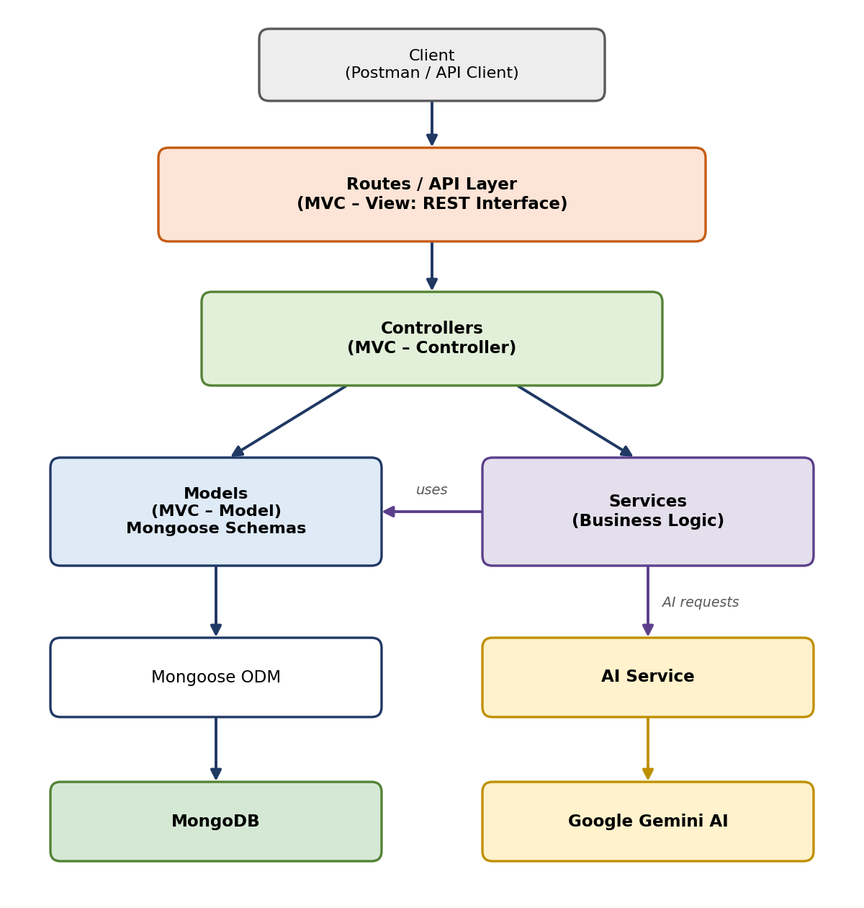
Figure 2: MVC Architecture of ContentGen
Figure 2 shows that the controller communicates with the models for data operations and with the services for business logic. The AI Service, a specialised service, is the only component that communicates with Google Gemini AI, while all persistent data access passes through Mongoose to MongoDB.

3.4 Module Design
ContentGen is divided into functional modules. Each module has its own routes, controller functions, service logic and, where required, a model. The major modules are described below.

3.4.1 Authentication Module
This module manages the identity of users. It provides user registration, login, password hashing, JWT generation and token verification. During registration the password is hashed with bcrypt.js before storage. During login the submitted password is compared with the stored hash and, on success, a signed JWT is issued. Token verification is implemented as middleware that protects private routes.

3.4.2 User Management Module
This module manages user information and access. It stores the name, email and role of each user, allows an Admin to assign or change roles, and supports access control decisions by supplying the role used by the authorization middleware. Sensitive fields, such as the hashed password, are never returned in responses.

3.4.3 Blog Management Module
This module provides the core content operations: creating, reading, updating and deleting or managing blogs. It also controls the draft and publishing states of a blog, so that content passes through the workflow described in Section 3.10 before it becomes visible to readers. Authors may modify only their own posts, whereas Editors and Admins have wider control.

3.4.4 AI Module
The AI Module provides AI blog generation and AI summarization. It receives a topic or existing blog content, prepares a suitable prompt, calls the Google Gemini AI API through the AI Service, and returns the generated text to the client. Prompt processing and Gemini API integration are contained in this module only, and the API key is kept in environment configuration rather than in source code.

3.4.5 Comment Module
This module allows users to create comments on published posts and to view the comments of a post. Comment moderation is supported so that Admins and Editors can review and remove inappropriate comments. Each comment is linked to both the user who wrote it and the post to which it belongs.

3.4.6 Category and Tag Module
This module organises content into categories and tags. Categories group blogs by subject, and tags describe specific topics. Both are used for content filtering, allowing readers to retrieve blogs that belong to a particular category or carry a particular tag.

3.4.7 Search Module
The Search Module enables users to search and retrieve relevant blog content. A search request contains a keyword, which is matched against blog content using MongoDB query capabilities through Mongoose. Only published posts are returned to readers, and results can be combined with category or tag filters.
In addition to the modules above, the architecture includes two supporting modules. Media Metadata stores information about images associated with posts, such as the photo reference held in the post record. Analytics represents the information derived from stored data, such as the likes recorded for a post, that helps to understand content engagement.
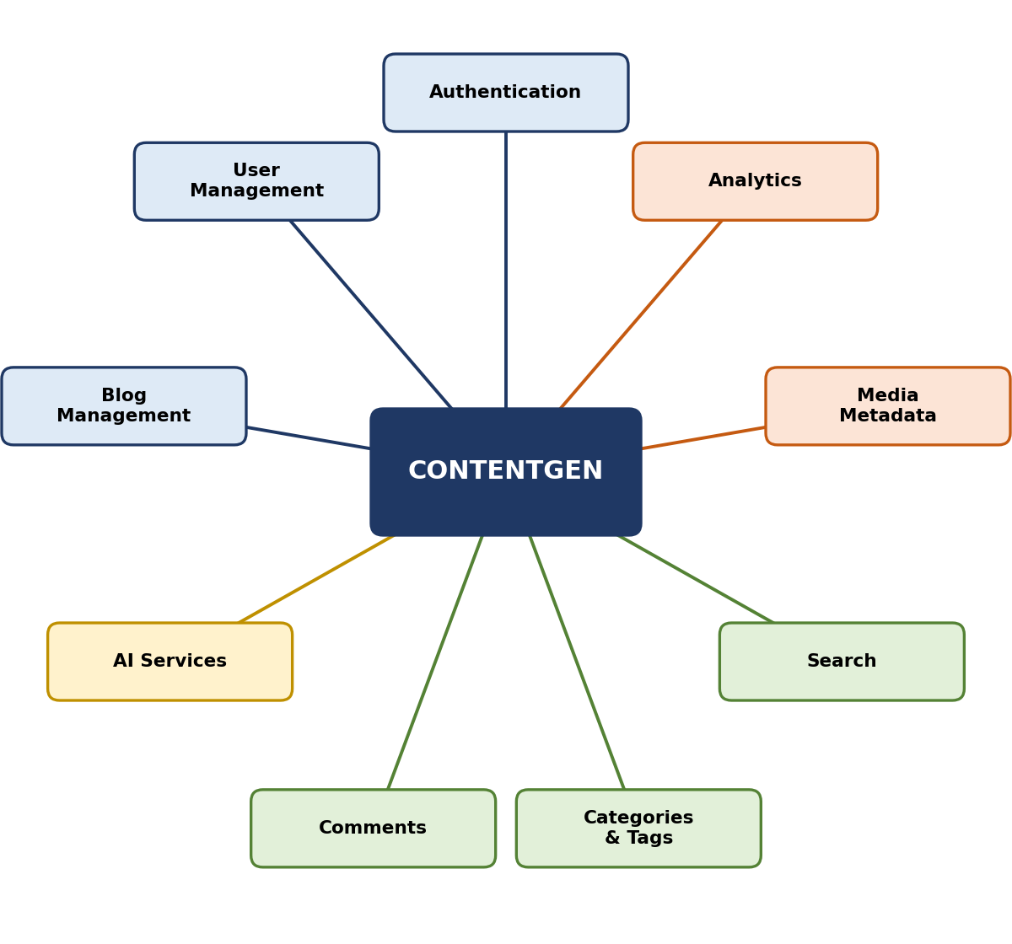
Figure 3: ContentGen Module Architecture

3.5 User Role and Permission Design
ContentGen uses Role-Based Access Control (RBAC) to restrict operations according to the role of the authenticated user. Four roles are defined, and each user is assigned exactly one role. The permissions of each role are summarised in Table 3.2.
Table 3.2: Roles and permissions in ContentGen
Role | Permissions
Admin | Manage users; manage roles; moderate comments; manage system resources
Editor | Review content; approve posts; manage the publishing workflow; moderate comments
Author | Create posts; edit own posts; manage drafts; use AI content generation
Reader | View published posts; search content; submit comments

The Admin has full administrative control over users, roles and system resources. The Editor is responsible for the quality of published content and controls the approval and publishing workflow. The Author produces content and may use the AI features, but can manage only their own posts. The Reader has the most limited role and can only consume published content and participate through comments.
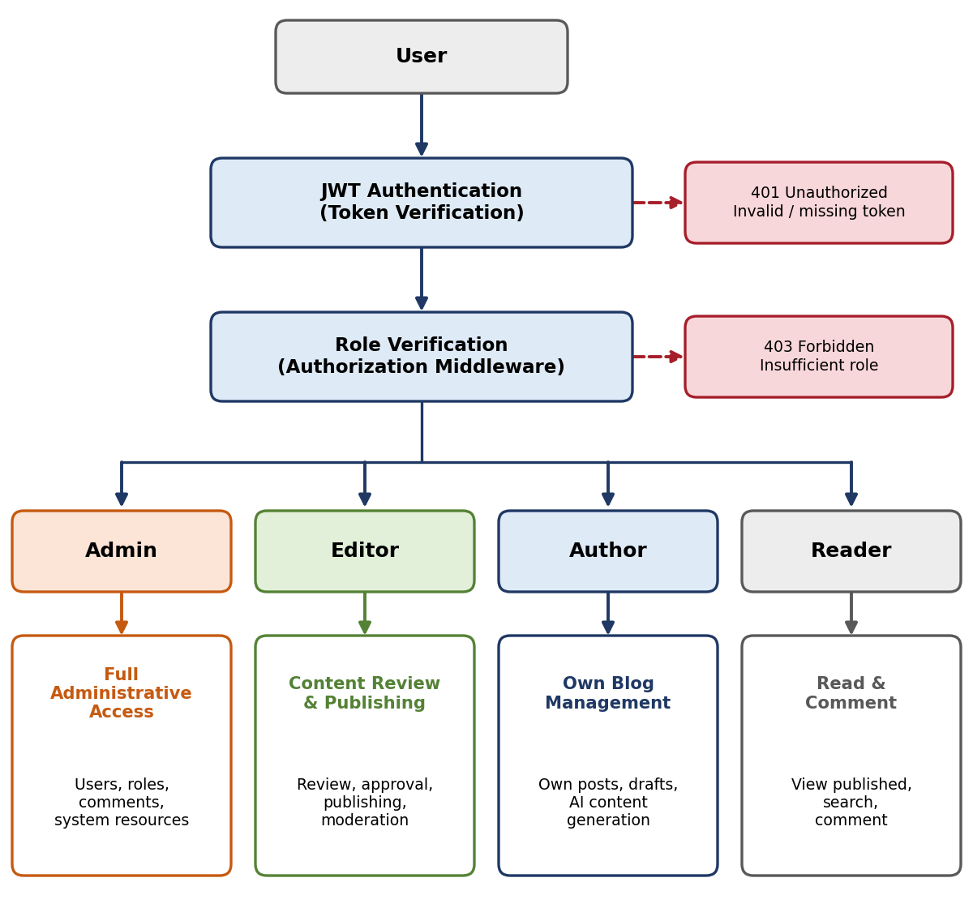
Figure 4: Role-Based Access Control Design
As illustrated in Figure 4, every request first passes JWT authentication. A missing or invalid token results in an unauthorised response. The role is then verified, and a request that exceeds the permissions of the role is rejected with a forbidden response. Only permitted requests reach the controllers.

3.6 Database Design
ContentGen uses MongoDB, a document-oriented NoSQL database, to store data as flexible JSON-like documents. This model suits blog content, which is text-centric and may evolve over time. Mongoose is used as the ODM layer. It defines schemas, applies validation rules to fields, provides models for database operations and maps application objects to MongoDB documents. The core entities are described below.
Table 3.3: User entity
Attribute | Description
_id | Unique identifier of the user, generated by MongoDB
name | Name of the user
email | Email address used to identify the user during login
password | Password of the user, stored only as a bcrypt.js hash
role | Role of the user (Admin, Editor, Author or Reader)

Table 3.4: Post entity
Attribute | Description
_id | Unique identifier of the post
userID | Reference to the user who created the post
name | Name of the post
photo | Image associated with the post
message | Main content of the post
likes | Like information recorded for the post
timestamps | Creation and update times, maintained by the Mongoose timestamps option

The Comment and Category models are logical entities of the system. A comment stores its own identifier, its content, and references to the user who wrote it and to the post it belongs to. The detailed field lists of these models are finalised during implementation. The blog workflow described in Section 3.10 also requires each post to carry its publication state.
The logical relationships between the entities are as follows:
- User and Post: one user can create many posts, while each post belongs to exactly one user through the userID reference (one-to-many).
- User and Comment: one user can write many comments, and each comment is written by one user (one-to-many).
- Post and Comment: one post can receive many comments, and each comment belongs to one post (one-to-many).
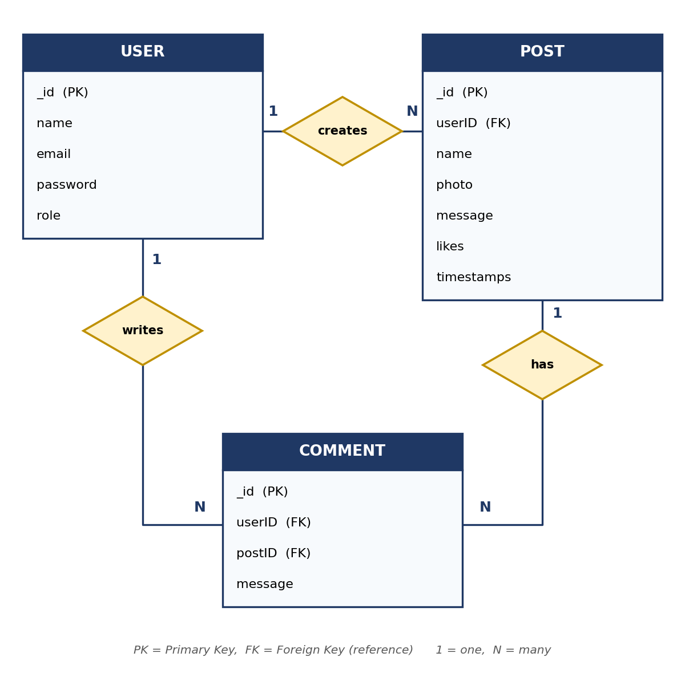
Figure 5: ContentGen Entity Relationship Diagram

3.7 API Design
The backend exposes a REST (Representational State Transfer) API. Resources such as users, blogs and comments are identified by URLs, and operations on them are expressed through standard HTTP methods. The API is stateless: every request carries the information needed to process it, including the JWT for protected routes. The four methods used and their purposes are shown in Table 3.5.
Table 3.5: HTTP methods used in the ContentGen REST API
HTTP Method | Purpose
POST | Create resources
GET | Retrieve resources
PUT | Update resources
DELETE | Remove resources

The representative endpoints of the system are listed in Table 3.6.
Table 3.6: Representative API endpoints
Endpoint | Description | Access
/api/auth/register | Registers a new user; the password is hashed before storage | Public
/api/auth/login | Authenticates a user and returns a JWT | Public
/api/blogs | Creates, retrieves, updates and deletes blog posts using POST, GET, PUT and DELETE | Role-dependent
/api/ai/generate-blog | Generates blog content for a topic using Google Gemini AI | Authenticated
/api/ai/summarize | Generates a summary of existing blog content using Google Gemini AI | Authenticated
/api/comments | Creates and retrieves comments; moderation is restricted to Admin and Editor | Role-dependent

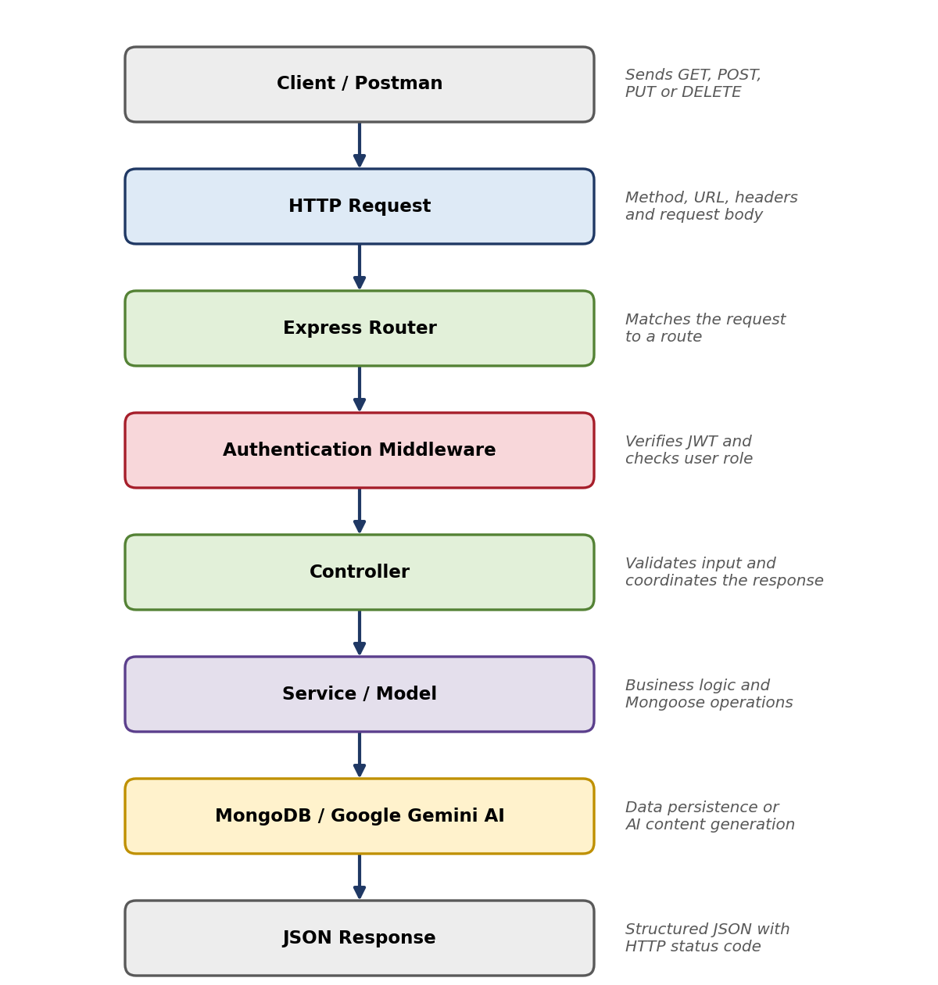
Figure 6: REST API Request and Response Flow
Figure 6 shows the path of a request. The Express router selects the route, the authentication middleware verifies the token, the controller processes the request, and the service or model accesses MongoDB or Google Gemini AI. The result is always returned to the client as a JSON response.

3.8 AI Integration Design
The AI features are provided through Google Gemini AI. The backend never exposes the AI service directly to the client. All requests pass through the ContentGen API, which allows authentication, validation and rate limiting to be applied to AI usage.
AI Blog Generation. The user enters a topic. The backend receives the request and validates it. The AI Service then prepares a prompt from the topic, sends the prompt to Google Gemini AI, and receives the generated blog content. The content is returned to the client as the backend response, and the Author may then review, edit and save it as a draft.
AI Summarization. The user submits existing blog content. The backend receives the summarization request, and the AI Service builds a summarization prompt containing the content. Google Gemini AI generates the summary, which is returned to the client in the backend response.
If the Gemini service is unavailable or returns an error, the AI Service reports the failure to the centralized error handler so that the client receives a meaningful error response instead of a system failure.
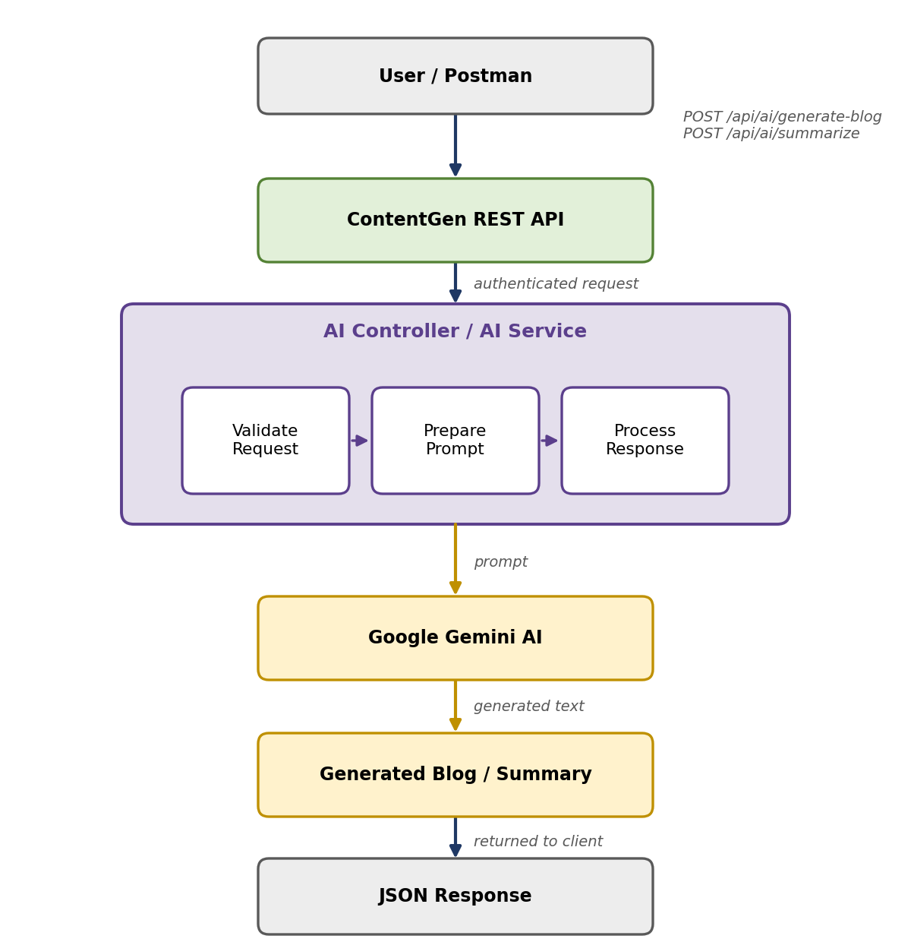
Figure 7: Google Gemini AI Integration Design

3.9 Security Design
Security is treated as a core design concern of ContentGen. The following mechanisms are applied, and their order of execution is shown in Figure 8.
- JWT authentication: after login, the user receives a signed token that must accompany requests to protected endpoints. This keeps the server stateless.
- bcrypt.js password hashing: passwords are hashed with a salt before storage, so plain-text passwords are never saved.
- Role-based authorization: middleware compares the role of the user with the roles allowed for the requested operation.
- Input validation: incoming data is checked for required fields and correct formats before processing.
- Input sanitization: input is cleaned to prevent injection attacks and harmful content from reaching the database.
- Rate limiting: the number of requests from a client within a period is limited to reduce abuse and protect the AI service.
- Protected API routes: all routes that modify data or access private resources require authentication.
- Centralized error handling: errors are handled in one place and returned in a consistent form without exposing internal details.
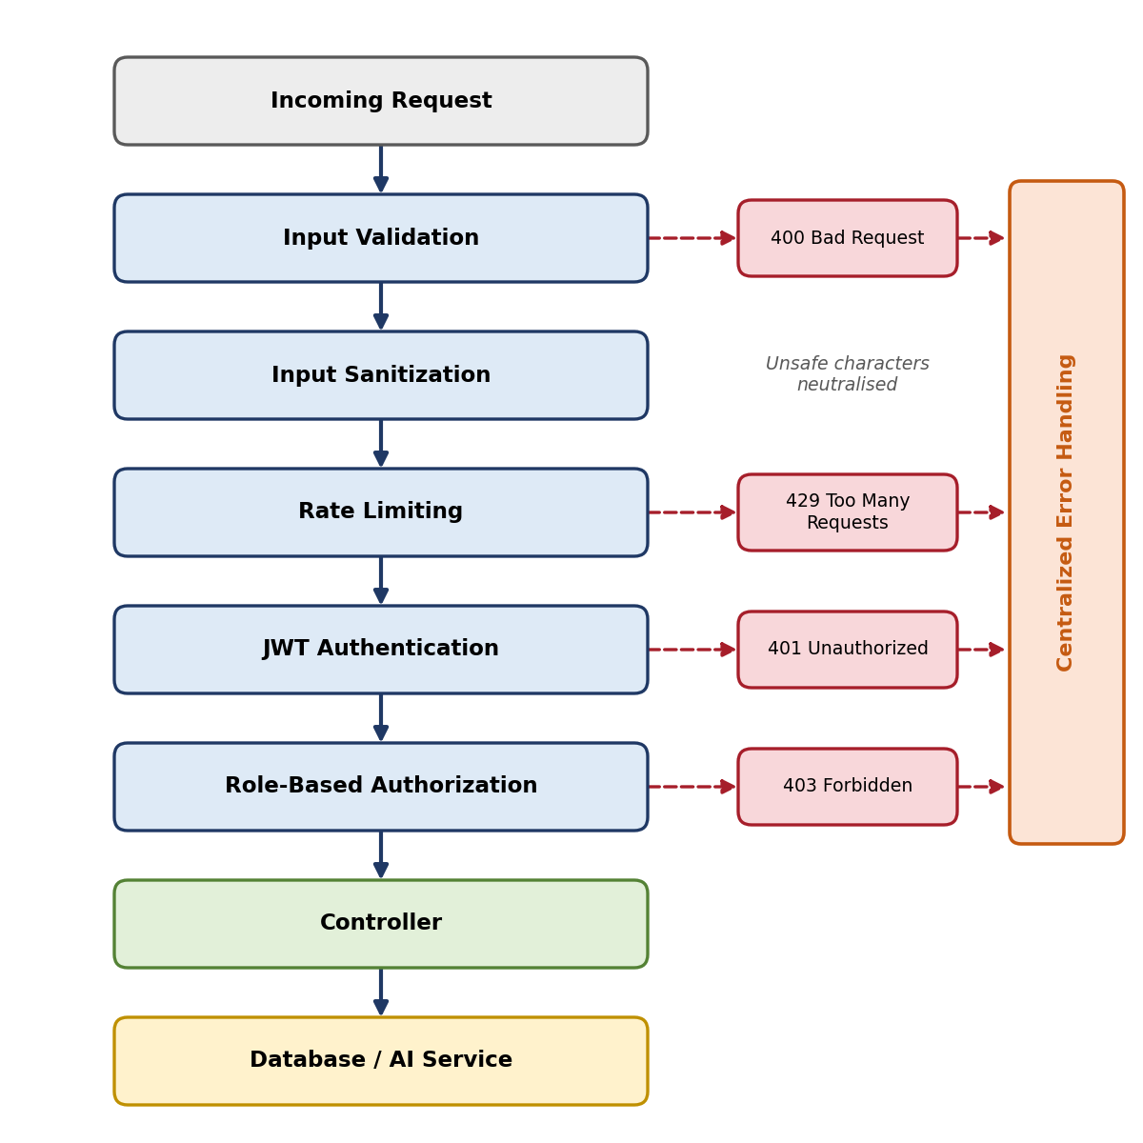
Figure 8: ContentGen Security Architecture

3.10 Blog Workflow Design
A blog passes through a controlled lifecycle so that only reviewed content is visible to readers. The states of the lifecycle and the responsible roles are given in Table 3.7.
Table 3.7: Blog lifecycle states
State | Description | Responsible Role
Draft | The post is being written or revised and is not visible to readers | Author
Pending Approval | The post has been submitted and awaits an editorial decision | Editor
Scheduled | The post is approved and set for publication at a later time | Editor / Admin
Published | The post is visible to readers | Editor / Admin

The Author creates the blog and keeps it in the draft state until it is ready, then submits it for review. The Editor reviews the content and either approves it or rejects it. A rejected post returns to the Draft state so that the Author can revise it. An approved post is scheduled or published immediately. The Admin oversees the system and may intervene in any stage when required.
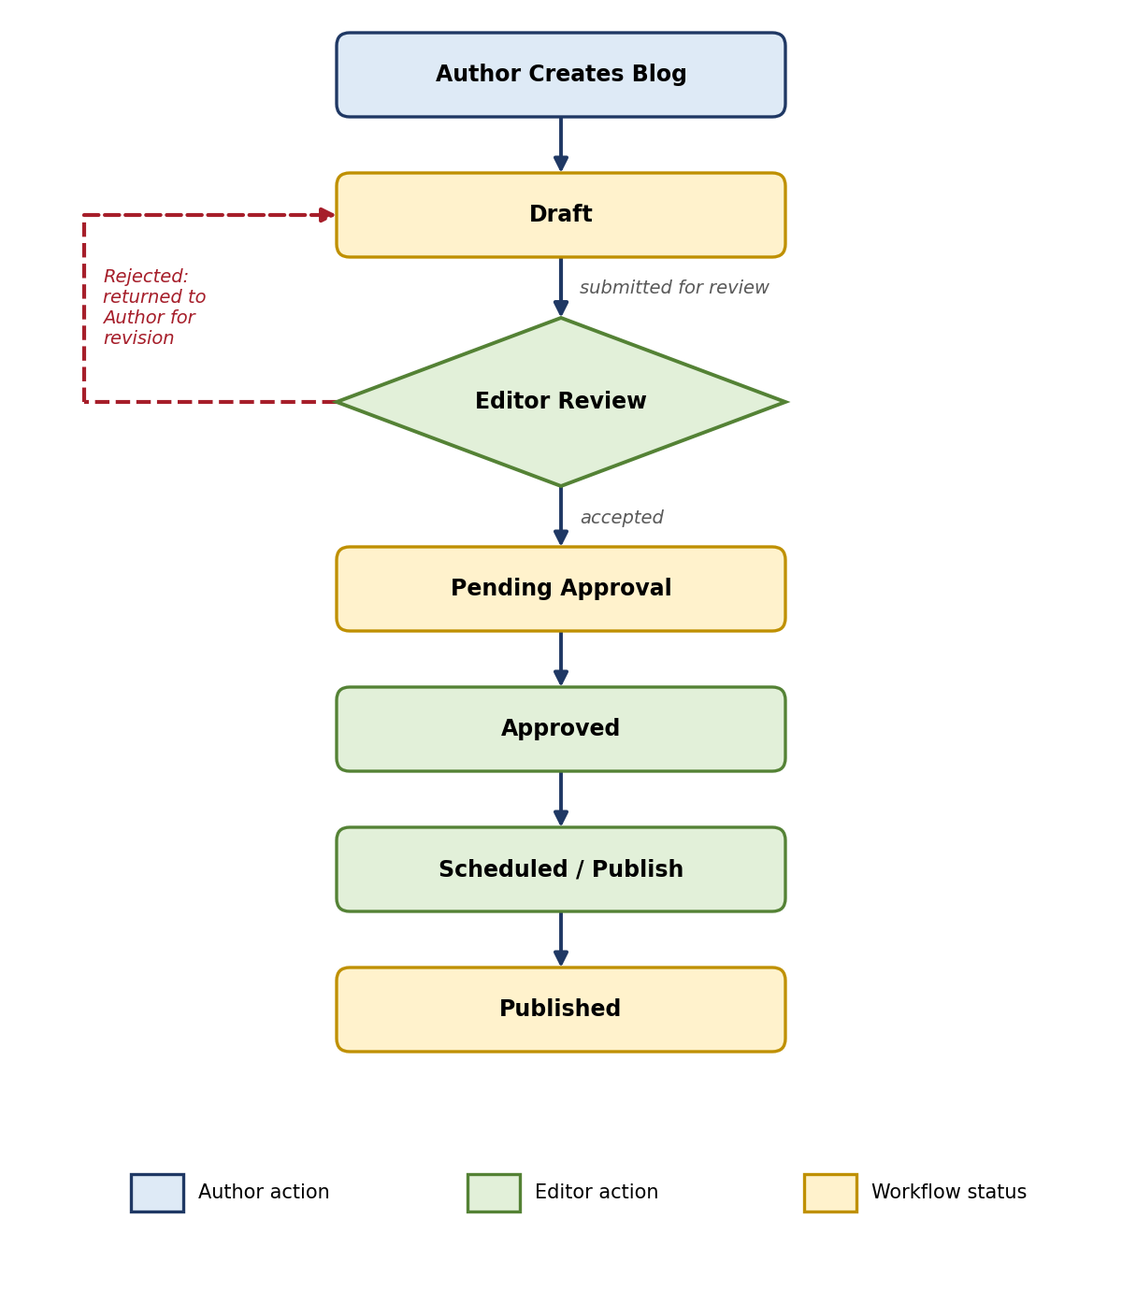
Figure 9: Blog Content Publishing Workflow

3.11 User Interaction / Use Case Design
Figure 10 summarises the interactions between the four types of users and the system. The Admin manages users and roles and moderates comments. The Editor reviews blogs, approves content and manages publishing. The Author creates and edits blogs and uses the AI features to generate and summarise content. The Reader reads and searches blogs and adds comments.
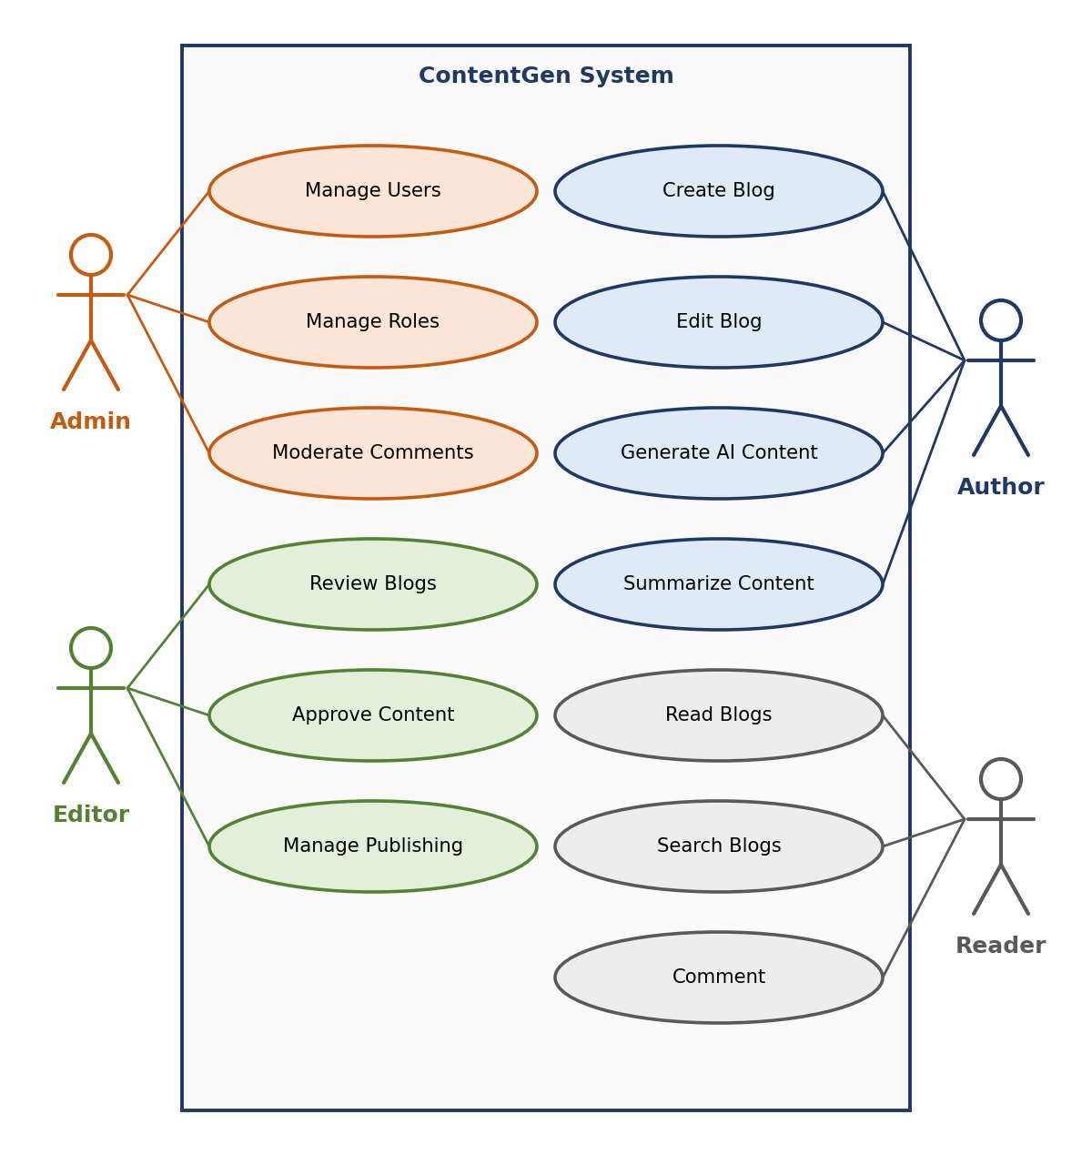
Figure 10: ContentGen User Interaction Diagram

3.12 Interface and Response Design
ContentGen is primarily a backend REST API and has no graphical interface of its own. Clients interact with it through HTTP requests and receive structured JSON responses, together with a suitable HTTP status code. The response categories are described in Table 3.8.
Table 3.8: Response categories
Response Type | Typical Status | Description
Success | 200, 201 | Confirms that the operation succeeded and returns the requested or created data, for example a list of published blogs
Authentication | 200, 401 | A successful login returns a JWT; missing or invalid credentials or tokens produce an unauthorised response
Authorization | 403 | The user is authenticated but the role does not permit the operation
Validation error | 400 | Describes the input that is missing or invalid
Error | 404, 429, 500 | Reports a missing resource, too many requests or a server-side failure through the centralized error handler
AI response | 200 | Returns the text generated by Google Gemini AI as a blog or summary; a failure of the AI service is reported as an error

The exact fields of each response are fixed during implementation. The design requires only that responses are consistent: every successful response returns data in JSON, and every error response returns a clear message that helps the client correct the request.

3.13 Design Principles
The design of ContentGen is guided by the principles in Table 3.9, which also show how each principle is applied.
Table 3.9: Design principles applied in ContentGen
Principle | Application in ContentGen
Modularity | The system is divided into independent modules such as authentication, blogs, comments, AI and search
Separation of concerns | MVC separates routes, controllers, services and models, and AI logic is isolated in the AI Service
Scalability | The stateless REST API with JWT authentication and the document-oriented MongoDB database allow the system to grow
Security | Layered protection through validation, sanitization, rate limiting, JWT, bcrypt.js and RBAC
Maintainability | Small, focused components and a consistent structure make defects easier to locate and fix
Reusability | Middleware and services, such as authentication and validation, are shared by many routes
Data integrity | Mongoose schemas and references between users, posts and comments keep stored data consistent
API consistency | Standard HTTP methods, predictable endpoints and uniform JSON responses

3.14 Design Summary
The Project Design Phase transforms the requirements of ContentGen into a coherent technical design:
- System architecture: a five-layer backend covering the client, API, security, application and data layers.
- MVC structure: Mongoose models, controllers and services, with the REST API replacing the traditional view.
- Database structure: MongoDB entities for users, posts and comments with defined one-to-many relationships.
- API structure: REST endpoints using GET, POST, PUT and DELETE with JSON responses.
- AI integration: a dedicated AI Service that connects the backend to Google Gemini AI for blog generation and summarization.
- Security architecture: validation, sanitization, rate limiting, JWT authentication and role-based authorization.
- User-role permissions: distinct capabilities for Admin, Editor, Author and Reader.
- Blog workflow: a controlled lifecycle from Draft through Pending Approval and Scheduled to Published.

3.15 Conclusion
The Project Design Phase establishes the technical blueprint for implementing the ContentGen system. It defines a layered and modular architecture, the MVC organisation of the backend, the database entities and their relationships, the REST API, the integration of Google Gemini AI, the security mechanisms, the permissions of each user role and the lifecycle of blog content. Together these decisions ensure that the system is secure, maintainable and ready to scale.
This design provides a clear foundation for the next phase, Project Planning / Development, in which the modules, models, routes, controllers and services described in this chapter will be implemented and tested.

